Lebanese American University

Department of Computer Science & Mathematics

CSC 458 – Game Programming



Game Design Document

Data: 27/05/2021

Project: The Quest

**Project “The Quest”**

*Saving the Princess*

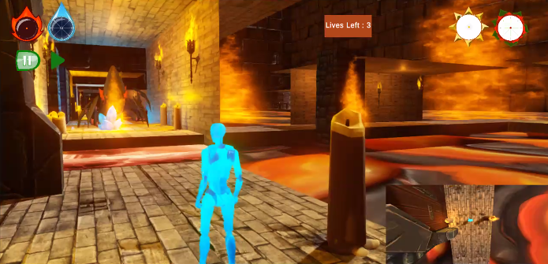**Genre:**

Third Person Shooter/Adventure.

**Theme:**

Dualism.

**Camera/Game Perspective:**

Third Person.

**Single vs Multiplayer:**

Single player.

**Target Audience:**

13+ years old children. Our game is designed to be fun for young children. It’s only violence includes destroying golems and spiders and its rules are simple: gathering collectibles and saving the princess. There number of collectibles collected and health are also shown, in addition to make it easy for young kids to understand the game. If the kid loses, he/she can respawn at a checkpoint or use the manual save/load system as well.

**Controls:**

Mouse and keyboard.

**Tech Stack:**

Unity version 2020.3.27f1

**Platforms:**

MS Windows.

**MVP (Minimal Viable Product) Game Moment:**

You can play the game for 10 minutes which includes the collection of collectibles boxes in addition to the killing of golems and slider. Finally placing the collectibles removes the wall so the player can reach and save the princess.

**Game Summary:**

“Project The Quest is a third person shooter where you play in 2 levels representing the 4 elements of nature. The levels contains collectibles and enemies. You have to pick the collectibles from the various locations in order to save the princess at the end. These enemies can be killed using a rifle. Once you get all the collectibles, you can go and save the princess.”

**Core Player Experience:**

Fun and adventurous.

**Central Story Theme:**

The protagonist is you, the hero and the main character of the game in addition to the princess, while the antagonists are the golems and spiders.

**Key Features:**

Player can shoot bullets from his rifle.

Player will lose health if they move on fire or get attacked.

Player can respawn at checkpoints if they lose.

Player can use the save/load system from the UI.

Player can advance to next level.

Player can collect collectibles.

Player can place these collectibles in the temple after picking them all to save the queen and win the game.

**Game Play:**

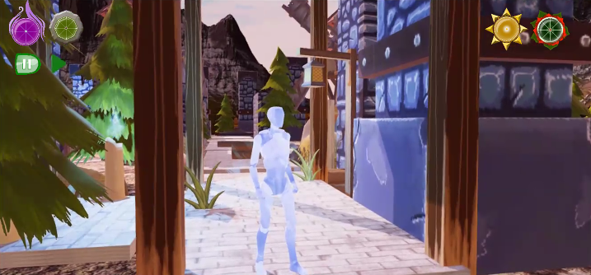 “The aim of the game is to gather all the collectibles and use them to destroy the wall and reach the princess.

The player can move using WSAD or arrow keys.

The player can jump using the space bar.

The player can click on the right mouse button to get the rifle and aim.

The player can shoot using the left mouse button if he is aiming.

The player can use P button to pause and the R button to resume the game.

The player can destroy the enemies by shooting them.

The player can monitor their health and collectibles collected.

The player can click on the left mouse button to place collectibles next to the princess tower.”

**Reference Games:**

None.